Case Studies in Undanax
The case studies presented here relate to the mining problems encountered in a fictitious country called Udanax. These studies are reproduced, with permission, from Mine Rehabilitation Environment and Health Protection: A Training Manual (UNEP and WHO, 1998). Trainers and trainees are encouraged to use these case studies as a tool to allow them to think freely in a situation where they are not limited by the practical problems that bedevil real-life situations, such as financial, political and time constraints. Having said this, these case studies are intended to prepare trainees to work in real-life situations. There is plenty of room to expand the case studies, and trainers are encouraged to develop the scenarios further and to prepare additional exercises, especially to bring out issues and topics of particular concern and interest to trainees.
Case Study 1 presents a general overview of the geography, economic situation, mining industry, and administration of the mythical country of Udanax. This section could be used as an extensive case study for Mine Planning and Environmental Risk Assessment.
Case Study 2 presents a scenario based on an existing tailings dam at one of the mines in Udanax. This storage facility was used between 1912 and 1972, and does not meet modern safety or environmental standards. This case study could be used for in conjunction with Tailings Containment and Environmental Risk Assessment modules.
Case Study 3 considers some issues of mine rehabilitation. Although mine rehabilitation is not specifically considered in this series of Trainer’s Manuals, the scenario has relevance to other topics in this series. You could use this case study in conjunction with Environmental Monitoring and Performance, Water Management, and Mine Planning. Remember that Mine Planning should include planning for closure, rehabilitation, and monitoring of the mine site.
Case Study 4 reflects on the failure of a tailings dam at an abandoned mine site. This resulted in a massive mudslide that damaged houses and roads and affected a number of waterways. This case study can be used as a resource for the modules: Managing Sulphidic Mine Wastes and Acid Drainage, Environmental Risk Management, Tailings Containment, and Environmental Monitoring and Performance.
Each scenario provides a number of questions that you can use as exercises. You can also develop other questions to suit your needs, or modify the scenario to reflect local conditions.
- THE COUNTRY CONTEXT
Introduction
The situation in Udanax is as follows: Consciousness of environmental abuse and pollution has been growing steadily in the country. However, there is still relatively little reliable documentation, and opinion is divided over how serious the issues really are.
There have been some attempts by authorities to control all types of pollution, but they have not been systematic, and results have not been satisfactory in all instances.
There is a growing conservation movement in the country and a keen interest in restoring disturbed lands.
Of particular concern has been the highly impacted disturbed land that has come about as a result of past mining practices. The present operating mining companies have been told that they now have to conform to new mining legislation. This law (known as the « Mining Act ») not only includes a requirement for a rehabilitation plan for ultimate closure but also that progressive rehabilitation needs to be undertaken on the presently operating properties. For those mines which have not as yet gone into operation, there is the requirement to have an operating plan and rehabilitation plan approved before they go into production.
Prime Minister Albuk Nahk has been made aware that many abandoned mining structures are collapsing, and are hazards to the population. Also, the Prime Minister, through his Ministry of International Affairs, has been told that the continuing export of the country’s “dirty” minerals is under scrutiny. Some multinational manufacturing companies are becoming conscious of maintaining their own environmental image and will eventually cease to purchase metal products from countries with irresponsible environmental practices.
Owing to these concerns, the Prime Minister commissioned a task force headed by a Deputy Minister to investigate the situation and provide recommendations. The task force comprised representatives from the Ministries of the Environment, Mining, Agriculture, Health, Labour, Industry, Transport and Energy. The mining and manufacturing industries, conservation groups, environmental groups and the general public made submissions to the task force.
The task force recommended that a new mining law be drawn up as soon as possible to address three prime factors: first, the health and safety of the population; second, the environment; and third, ultimate land use. The legislation was to give much broader powers to the relevant government officials and would complement existing legislation covering the environment, occupational health and safety, air, water and transport.
NATIONAL PROFILE
Geographical
Area: 700,000 km²; 1100 km of coastline
Terrain: undulating to flat, with higher elevations to the south
Climate: temperate to hot
Rainfall: Monsoonal: dry for 8 months, wet for 4 months
Population: 20 million, six cities with a population above 200,000
8% of the population belongs to poor minority groups.
Resources and Urban Services
Minerals and Energy: substantial minerals, oil, gas, coal, though little detailed exploration carried out
Agricultural Land: moderate productivity and diverse, extensive irrigation along the Udanax, Xan, Isos, Pantum and Yeo Rivers
Water Supply: limited surface and groundwater
Transport: good network between major towns and cities
GDP: 144 000 million pesos, 7200 pesos (US$ 1800) per person (see Table 1.1)
Economics and Industry
Energy and resource based, with heavy industry, some light manufacturing, and service industries represented. Extensive trade and commerce with foreign countries.
Agriculture is predominantly in the centre and north of the country, with many export crops based on irrigated production of fruit, vegetables and livestock. Fisheries are an export industry with plentiful stocks in the Sea of Udan. Some over-fishing is occurring in the Bay of Naxis.
Mining represents 7.9% of the GDP, and the export of refined metal is a major source of foreign currency. The fabrication of metal products is being promoted by the government in order to expand the economy by extracting greater value from the country’s natural resources.
Most manufacturing activity is concentrated in the three main towns (Udanax City, Port O’Cobo and Sonax). Petroleum production and refining is primarily in the dry interior of the country around Daxon. Agriculture is mostly near the coastal strip, and along the main river valleys where irrigation water is available. Mining operations are spread throughout the country with operations in both the temperate and the arid to semi-arid zones (Figure 1.1).
Industry output is shown in Table 1.1, employment is shown in Table 1.2 and total mineral production in Table 1.3 These data were supplied by the Ministry of Industry and the Ministry of Employment. Table 1.4 shows the pro rata apportionment of the mineral production which was achieved by the five leading mining companies in Udanax. The listing that follows contains some information about the owners of each mine, the location of the mines (see also Figure 1.1), their expected reserves and their working history:
Table.1.1 Main Origins of Gross Domestic Produce (in million Pesos)
Agriculture | 11,823
Building & Public Works | 18,198
Communications | 886
Hydrocarbons | 48,191
Industry | 14,574
Mining | 11,399
Other Branches | 9,816
Services | 5,436
Trade | 16,876
Transport | 6,504
GDP | 143,703
Exchange Rate 4 Udanax Pesos = 1 US Dollar
Figure 1.1. Map of Udanax
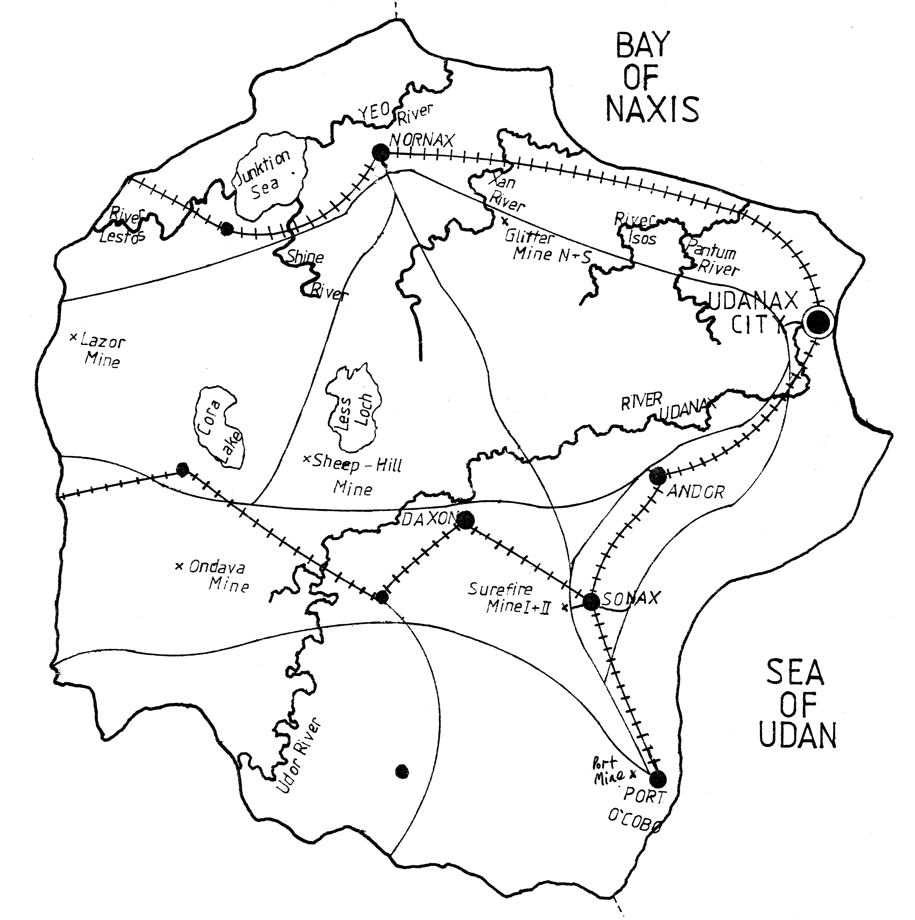
Legend:
Major Roads

Railway Track

River

Capital

City >200 000 Inhabitants

City 100 000 - 200 000 Inhabitants

Table 1.2. Structure of Employment
 | % OF TOTAL
Agriculture & Fishing |  | 40.1
Commerce |  | 11.1
Construction |  | 2.9
Electricity, Gas, Water |  | 0.3
Government, Community, Social and Personal Services |  | 29.9
Manufacturing |  | 10.2
Petroleum, Mining & Quarrying |  | 1.9
Transport |  | 3.6
TOTAL |  | 100.0

Table 1.3. Mineral Production Per Annum
Copper, kg | 2,662,740
Gold, g | 1,265,530
Lead, kg | 952,240
Silver, kg | 2,950
Zinc, kg | 2,210,520
Iron ore, tonnes | 1,920,000
Potash, tonnes | 70,120
Salt, tonnes | 115,850

Table 1.4. Mineral Production Split by Company
Company | Copper (kg) | Gold (g) | Silver (kg) | Lead (kg) | Zinc (kg) | Iron Ore (t)
Exploration Ltd. |  |  |  | 952 240 | 2 210 520
Ondava Mining Co. | 2 662 740 |  | 2 950
Int. Overseas Inc. |  | 765 330
Harpers Iron Ltd. |  |  |  |  |  | 956 000
Paddington Mining |  | 500 200 |  |  |  | 876 000
Total | 2 662 740 | 1 265 530 | 2 950 | 952 240 | 2 210 520 | 1 920 000

Exploration Ltd.
- International consortium with mines across the world
- Owner of the Glitter Mine North and South
- Located approximately 150 km south-east of Nornax in northern Udanax
- Active since 1950
- Glitter Mine North abandoned since 1980
- Glitter Mine South was opened in 1979
- Expected reserves for Glitter Mine South:
⇒ lead: 1 004 480 kg
⇒ zinc: 4 421 040 kg
- Surface area of mining: 2.4 km²

Ondava Mining Co.

- Government owned mining company, based in Udanax City
- Owner of the Ondava Mine
- Ondava Mine is located 100 km to the south of Cora Lake
- Active since 1984
- Expected reserves:
⇒ copper: 15 966 440 kg
⇒ silver: 17 700 000 kg
- Surface area of mining: 1.1 km²

International Overseas Ltd.

- International company specialised in gold and silver exploration
- Owner of Surefire I and II
- Located on the outskirts of Sonax
- Surefire I was closed in 1972
- Surefire II used since 1970
- Expected reserves for Surefire II:
⇒ gold: 5 358 710g
- Surface area of mining: 1.92 km² - Surefire I and 1.6 km² - Surefire II
Harpers Iron Ltd.

- Partly owned by the government, located in Sonax
- Owner of Lazor Mine
- Located close to the western border
- Active since 1981
- Expected reserves:
⇒ iron ore: 4 780 000 tonnes
- Surface area of mining: 0.96 km²

Paddington Mining

- Private company located in London, UK
- Owner of Sheep Hill and Port Mines
- Port Mine is located on the outskirts of Port O’Cobo
- Active from 1950 to 1958. Reopened in 1997
- Expected reserves:
⇒ gold ore: 10 128 000 g
- Surface area of mining: 0.5 km²
- Sheep Hill Mine is located 20 km to the south-west of Less Loch
- Active since 1979
- Expected reserves:
⇒ iron ore: 13 064 000 tonnes
- Surface area of mining: 1.47 km²

Administration
Government
Udanax has a constitutional monarchy with a prime minister and parliament. There are four provinces with governors and provincial parliaments; and 31 local government authorities. Many national regulations, including air and water quality standards, are enforced by local government officials.
Administration
The national government has thirteen ministries comprising development, industry, mining, health, labour, defence, environment, energy, transport, agriculture, finance, foreign affairs and internal affairs. Many ministries have provincial offices to implement procedures and regulations in the field.
Technical Services
Udanax has three universities (The National University of Udanax at Andor, Nornax Agricultural University, and Technology and Marine College at Port O’Cobo) and their research teams are interested in marine pollution, mine rehabilitation and climate and environment change. Engineering departments occasionally help industries with production problems. Several engineering consultants have offices in the country. They have been mostly involved in mineral exploration, development and rehabilitation, and in plant design and operation.
Environment
The Ministry of Environment is responsible for enforcing the environmental legislation and regulations. Regional offices are responsible for matters which are not of national or international importance, and local authorities take care of water and air quality, waste disposal and land use decisions within their jurisdictions. Emission standards are set nationally, but lower level authorities may set higher standards if they choose. EIAs must be carried out for all significant projects, with the Minister having the final say in a dispute. The government is very concerned to raise the standard of living within the country, and thus the Ministries of Development and the Environment have quite a stormy relationship.
Background data which is useful when judging the sensitivity of the ecology of Udanax to chemical pollution is shown in Table 1.5. Information concerning the vegetation in Udanax is given in Tables 1.6 - 8. Since Udanax is an imaginary country, any resemblance between the flora names and the names of flora in other countries is entirely coincidental.
Mining Legislation
As a result of the recommendations of the Prime Minister’s task force on disturbed mining land and mining operations, the Ministries of Mining and Environment prepared jointly new mining legislation that includes stronger requirements for environment protection, including rehabilitation. The new law will apply to developing, operating and abandoned mines. The draft legislation has been discussed with various government ministries, the mining industry, conservation groups, other industries, the agricultural sector and representatives from the provinces. The mining legislation will apply in parallel to existing environmental regulations on water and air pollution, and on EIA for mining projects.
Table 1.5. Environmental Sensitivity: Udanax
Coastline | 1100 km
Estuaries | 250,000 ha
Agricultural Land  % Irrigated | 200,000 km  10% i.e. 2,000 km
Ground Water Quality | Mostly good, but some aquifers are beginning to deteriorate as a result of mining and other industries
Surface Water Quality | Some waters close to heavy industry and mining are already polluted
Marine Water Quality | Polluted near harbours; otherwise OK
Industry Adjacent To -  Urban Areas  Agricultural Land  Coastline, Wetlands | Yes, light & heavy industry & mining  Yes, mining & some heavy industry  Yes, smelters, refineries, mining and heavy industry
Transport Through Urban Areas | Yes
Important National Species Of -  Land Animals  Migratory Birds  Fish & Other Marine Species | No  Yes  Yes, including some rare species
SOURCE: Department of Biology, National University of Udanax
Table 1.6. Shrubs in Udanax
SPECIES | MOISTURE | FERTILITY
Grey Dogwood | Dry to Mesic | Medium
Pussy Willow | Wet | Low to Medium
Red-Osier Dogwood | Moist to Wet | Low to High
Speckled Alder | Moist to Wet | Low
Common Juniper | Dry | Low to Medium
Alder | Wet to Mesic | Low
Choke Cherry | Dry to Mesic | Medium to High
Nannyberry | Moist to Wet | Medium
Highbush Cranberry | Moist to Wet | Medium to High
Sumac | Dry | Low to Medium
Hawthorns | Dry to Mesic | Medium to High
Raspberry | Dry to Mesic | Low to High
Currant | Mesic | Medium to High

Table 1.7. Forbs in Udanax
SPECIES | MOISTURE | FERTILITY
Clover | Dry to Mesic | Low to Medium
Birdsfoot Trefoil | Dry to Mesic | Low
Strawberry | Dry to Mesic | Medium
Canada Blue Grass | Wet to Moist | Medium
Tall Fescue | Dry to Mesic | Low
Creeping Red Fescue | Dry to Mesic | Low
Millet | Dry to Mesic | Low
Bent Grasses | Dry to Moist | Low to Medium
Wild Rye | Dry to Moist | Low to High
Rye Grain | Dry to Mesic | Low
Alsike Clover | Dry to Mesic | Low to medium
Timothy | Dry to Mesic | Low to Medium

Table 1.8. Trees in Udanax
SPECIES | MOISTURE | FERTILITY
Red Maple | Moist to Wet | Medium
Black Locust | Mesic to Dry | Low
Balsam Poplar | Dry to Wet | Low to High
White Birch | Mesic | Low
Trembling Aspen | Dry to Moist | Low to Medium
Eastern Red Cedar | Dry | Low to Medium
Tamarack | Moist to Wet | Medium to High
White Spruce | Moist to Wet | Low to Medium
Black Spruce | Moist to Wet | Medium
White Pine | Dry to Mesic | Low to Medium
Jack Pine | Dry | Low
Red Pine | Mesic to Dry | Low to Medium
White Cedar | Dry to Wet | Low to Medium
Red Cedar | Dry to Mesic | Low to Medium
Note: “mesic” means “moderate”.
The Legislation
As regards site rehabilitation, the draft legislation requires the following:
- Preliminary Study prior to any major disturbance by mining activities of the land/ water base. Major disturbance in advanced exploration is defined as removal of 500 tonnes or stripping of more than 2,500 square meters.
- If the mine goes to production, an Operating Plan must be prepared and adhered to.
- Before mine development or production can begin, a Rehabilitation Plan must be submitted by the company and approved by the Director of Rehabilitation in the Ministry of Mining.
- Prior to approval, the Rehabilitation Plan has to go to public review, and be endorsed by the Ministries of Environment, Labour and Mining.
- The company must undertake progressive rehabilitation in accordance with the Rehabilitation Plan unless for technical reasons the Director has approved an exception.
- An annual review of progress of safety of tailings dams and dump sites, and of rehabilitation is required by the Ministry of Mines.
- The plan may be amended at any time but must obtain approval for any changes from the Director, in consultation with the Ministries of Environment and Labour.
- If a company contravenes the Act it is subject to a fine of up to 120,000 pesos per day while in contravention
- Where significant land is disturbed, a security deposit fund is required, and it is held by the government. The funds can be used by the government to ensure that the site is appropriately rehabilitated should the operator default in the rehabilitation for whatever reason. If there are funds remaining after successful completion of the rehabilitation, they will be returned to the operator with accrued interest.
- For the owner of an abandoned mine, the same rehabilitation planning is required under the same conditions as an operating or closed-out mine. If an owner cannot be found, the property becomes the obligation of the state, which may either confiscate the site or place a lien against the property for the cost of the work done to rehabilitate it.
Exercises
- Discuss the priority that mine site rehabilitation probably has in the minds of:
  - politicians
  - mining industry managers
  - local people near mines
  - inhabitants of Udanax City
- Discuss, from your own background knowledge, the importance that public involvement and administrative transparency has in development decisions in Udanax. How will this affect the rehabilitation of individual properties?
- Where in Udanax would be located the information, expertise and knowledge that is required for site rehabilitation? Prepare a list of such support services, and discuss how capacity could be strengthened in order to provide a better service to the entire mining sector.
- There is no mining industry forum in Udanax where a common approach or policy on rehabilitation can be discussed by companies. Discuss how to create such a forum. Prepare a draft policy by the forum on rehabilitation, including abandoned sites.
- On which mining sites in Udanax could cyanide contamination be expected?
- Which of the mines are likely to require tailing dams?
- What possible impacts on occupational health may be caused by the exploration of minerals by the companies already present in Udanax?
- Do the environmental impacts caused by each of the mining companies differ from one another? Explain in which cases and how they differ.
- Discuss the different expenditures for site rehabilitation that may be necessary for each company.
- Review critically the draft legislation proposed by the task force from the point of view of:
  - effectiveness in achieving satisfactory rehabilitation
  - administrative burden to the government
  - cost of compliance
  - public participation
- Discuss how the legislation should be implemented in the field.
- Discuss and proposed the criteria or conditions under which the proposed security deposit will be refunded in full.
Further exercises to be developed by the trainer.

- SUREFIRE MINE TAILINGS SITE I
Background
The Surefire mine is on the outskirts of the town of Sonax in southern Udanax. The disused tailings impoundment is 22 metres high with a slope inclination of from 1.5H:1V to 2H:1V, and overlooks two settlements which together contain 250 residences. The nearest houses are less than 80 metres from the base of the slope.
Between 1912 and 1972, 58 million tonnes of tailings were deposited over an area of 192 hectares. The area surrounding the tailings is flat and there was no habitation in the immediate vicinity during the operation of the mine (Figure.2.1).
From preliminary examination it has been determined that the dam was built by the upstream method with spigotted tailings which were not controlled by any design criteria, thus producing a loosely packed mixed grain size material.

Figure.2.1. Location of Tailings Relative to Housing

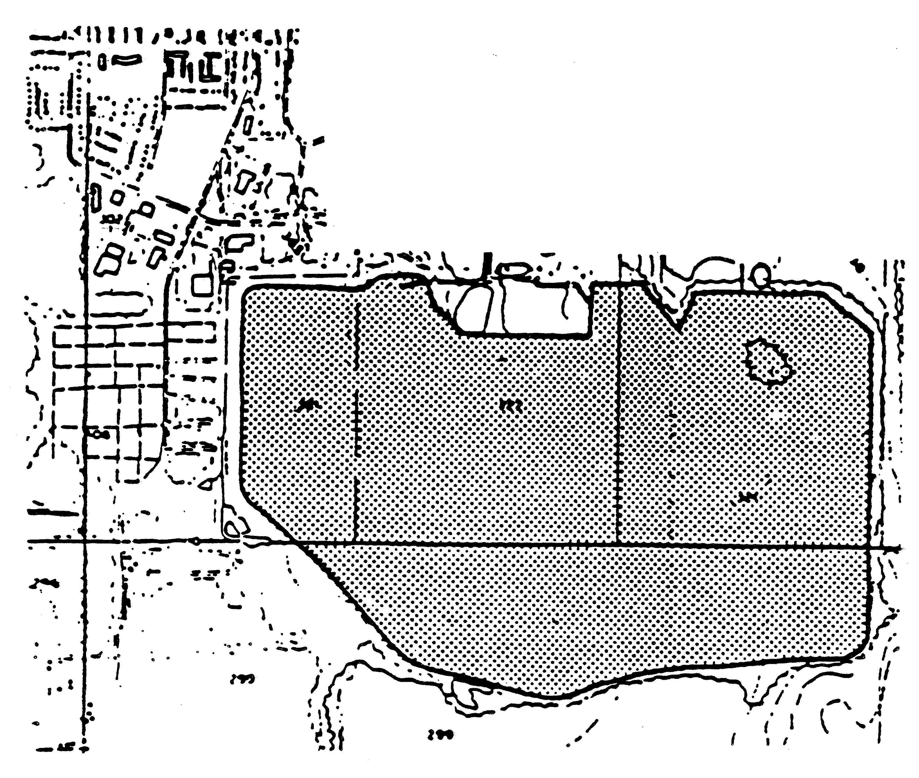
Tailings Dam
There is water seeping from the toe of the slopes and sand boils near the toe are common. This seepage combined with internal piping and the surface runoff has caused the formation of deep gullies and rotational slips on the slope. The gullies extend to roughly half of the dam elevation and are progressing to the crest. There is a marshy, swampy area at the base of the dam, with numerous tamarack trees, separating the site from the residences.
There is also evidence of buried timbers within the dam. These timbers act as pathways for water and weaken the structure. This provides further evidence that there was little thought in the planning and operation of the structure. The decant towers once used to drain the tailings pond have been blocked for a long time. There are no spillways to drain the ponded waters on the upper surface of the dam. These ponds recharge the phreatic level within the tailings, and further act to destabilise the dam.
In addition, there are many longitudinal and transverse cracks on the top near the crest of the dam as well as some slumping along the perimeter of the dam.
Another problem is that many of the local children play on the slopes, despite warning signs and attempts to fence the site. In rehabilitation efforts, this must also be taken into consideration.
Tailings Surface Rehabilitation
The situation at the site is clearly very serious. Once the most serious problems have been addressed, it will be necessary to rehabilitate the tailings impoundment. The following information is relevant to that task.
With the removal of the ponds from the surface of the tailings, except for two swampy, marshy areas, it is also necessary to contour and vegetate the upper surface and the slopes. The flatter slopes will reduce the flow velocities of surface runoff thus reducing erosion and gullying effects. To ensure the long term stability of the perimeter slopes and their suitability for the establishment of vegetation, it will be necessary to landscape the steeper parts. An analysis of the tailings on top of the disposal site and on the slopes shows that there is very little nutrition or organic matter in the tailings. However, there are no toxic chemicals or elements present either.
Exercises
- Should the tailings dam fail and the tailings liquefy, what would happen?
- Why is this site particularly dangerous?
- Evaluate the hazards and risks pertaining to the Surefire Mine Tailings Site I.
- Drawing on your answer to question 3, what would be your actions, in order of priority, in response to what you have seen of the site. In particular, what would you do to enlist the assistance and co-operation of the neighbouring community in addressing the problems here. Assume that you have just discovered it. Do not assume that you are an expert in tailings management (unless of course you do have expertise in this area).
- Unless you or a member of your team is an expert in ameliorating a dramatic situation such as this, you will have to call in experts. In which fields would they have expertise? At what point would you call them in?
These training modules have been designed to assist in the development of best practice environmental management, not for experts in any particular field. Thus you may not have the expertise required to handle a tricky situation like this. However, you should probably have views on what could be done to address the problems here, and you should therefore attempt the questions that follow.
- In considering all the factors that could cause major failure of the dam, what would be your first priority to stabilise the dam?
- Supposing you have selected the removal of the ponded water on the dam, how would you go about removing the water?
- On the accompanying contour map, sketch the best plan in your opinion for draining the ponds.
- In constructing the ditches and spillways and remembering they will have a relatively strong flow of water, how would you design them?
- Once you have drained the ponds, how would you determine how successful you have been in lowering the phreatic level? Describe your procedure.
- If the walls of the dam fail, from the information that you have been given about the site, what would be the nature of the catastrophe?
- Along the perimeter and near the crest on top of the dam, a number of features were observed. These were longitudinal cracks, transverse cracks and slumping. What do these features indicate and if they are not rectified what would be the results?
- What other features on the site would indicate weak or unstable foundations?
- With this obvious, unstable, dangerous slope, how would you proceed to stabilise it, give reasons for each step?
- In revegetating the tailings, what sequence of steps should be taken?
- Assuming that you have managed to safely stabilise the tailings impoundment, describe the monitoring programme you will set up. Give details for what parameters you will monitor, how often and how far into the future.

Further exercises to be developed by the trainer.
- ONGOING REHABILITATION AT PORT MINE
This case study examines only a few aspects of rehabilitation. Trainers may well want to, and should feel at liberty to, further develop it by bringing out aspects of tailings dam management and rehabilitation, cyanide residues and risks, etc.
Background
Port Mine is on the outskirts of Port O’Cobo. It is an underground gold mine, with the primary remaining parts of the ore body located beneath the western suburbs of the town. The mine was run by the government in the 1950’s, and was reopened by a small mining company, Paddington Mining, when it was privatised in the late 1990s. Paddington also own Sheep Hill Mine.
The residents of those suburbs are wealthy by Udanaxian standards, and are very concerned about the value of their properties and the quality of their environment. Several leading members of the community live there, so they have a strong influence over the town administration. While the community was initially opposed to the reopening of the mine, the owners have developed a good relationship with them, through having paid careful attention to their concerns.
Being close to the sea, the mine site is quite windy. It experiences a higher than average rainfall.
Siting and Noise Control
As the existing shaft was unsuitable for safety reasons, the initial challenge for the company was to find an acceptable location for a new shaft. Several options were investigated before Vodon valley was chosen. Although not the shortest or cheapest access route to the ore body, it was decided to take a less direct route in order to minimise disturbances from the mine’s operations. The advantage of Vodon valley is that, while it is only 300 m from a residential area, the shaft headgear is hidden from the houses by a small hill and a 100 m strip of black spruce trees.
Noise is naturally a big concern for the environmental managers at Port Mine. They have considered four main options for controlling noise at the operation:
- muffling the machinery;
- modifying the machinery;
- operating the machinery only during the day; and
- using waste rock to increase the barrier between the community and the mine.
Water Management
By considering water management as an integral part of the mine from the planning stage, the landscape was utilised in a way that required a minimum of engineering. While the settling ponds, dam and wetlands were artificially created by the company, they all now function so effectively that physical maintenance is rarely required.
There are three settling ponds, which are used as the first step in removing the mine water’s principal impurities, iron, arsenic and manganese. Eventually, one of the ponds will become an evaporation basin. When the sludge in the ponds dries, the metals become fixed.
Upon leaving the settling ponds, water flows into a constructed dam, which serves as a wetland. Several species of reeds and rushes were introduced there when the dam was constructed. The dam’s primary function is as a sedimentation pond for clay particles suspended in runoff from the mine site. After rain, the dam water can be highly turbid, but the clay particles are precipitated almost immediately owing to the high levels of calcium and magnesium in the water.
From the dam, the water flows down a steep channel to a much larger constructed wetland. The stream is lined and the flow is interrupted with branches cut from tamarack trees. The wetland is the mine’s last means of cleaning its water before it leaves the site. It serves as a settling area, natural metals removal area and flood protection zone.
The water flows from the wetland into the Vodon river. At this point it generally meets statutory requirements without needing further treatment.
Revegetation
Even though the mine is still in its early stages, some areas are already being revegetated. The trees and shrubs in these areas were planted as tubestock along ploughed rows to facilitate rapid establishment. There is no natural seed stock in the topsoil as the site was overgrown by alien species when it fell into disuse. Various fast-growing species adapted to the local, wet climate are being planted.
Exercises
- What are likely to be the twin advantages of the hill and trees that lie between the mine and the neighbouring community?
- Consider the various options for controlling noise at the mine. Discuss their pros and cons.
- What do you think is the reason behind converting a settling pond into an evaporation basin?
- What would you do with the sludge that accumulates in the evaporation basin?
- Apart from aesthetic reasons, why were reeds and rushes planted around the dam?
- Why do you think the stream from the dam to the wetland was lined? Why were branches placed across it?
- Discuss the shortcomings of the procedure used to revegetate the mine site. Why do you think this procedure was chosen? What longer term solution could be used in tandem with this procedure?
- “The owners have developed a good relationship with [the community], through having paid careful attention to their concerns.” How would you go about establishing these concerns initially, and staying in touch with the community throughout the life of the mine?
- Prepare the outline of the mine’s monitoring programme. Ensure that it is specific to Port Mine. Include physical (including tailings dams), chemical and environmental impact monitoring.
- Examine what the company will need to do about closure of the mine, from planning through to actual closure, especially in the context of the tunnels being underneath Port O’Cobo. Ensure you give attention to post-closure land use.

Further exercises to be developed by the trainer.
- TAILINGS DAM FAILURE AT GLITTER MINE NORTH
Tailings Dam Failure
In October, 1994, a major tailings dam failure occurred at an abandoned mining property, the Glitter Mine, located approximately 150 km south-east of Nornax in Northern Udanax. A map of the mine site is shown in Figure 4.1. The dam failure resulted in a massive mud slide of liquefied tailings material which flowed through the breach in the dam, across forested country, engulfed 22 residences, severed a major road, a local road, and deposited sediments into Oxan Creek. The tailings then flowed east approximately 1.5 km into the Xan River. The tailings destroyed a 1 km section of the main Highway P4 and deposited large quantities of tailings along the creek bed. Fortunately, no one was killed in the incident. The depths of the tailings were variable with the maximum recorded being 12 meters. The volume of the tailings released was estimated to be 350 000 cubic meters.
The tailings spill created a plume of finer sized material in the Xan River, which travelled at a rate of approximately 0.5 km an hour, eventually reaching over 100 km. past the town of Woodville on the Xan River. The plume of material in the river had concentrations of lead, cyanide and arsenic, all of which exceeded the acceptable water quality standards.
Mining and Tailings Operations
It is understood that the tailings area (Lagoon I) was operated up until about 1961 as a gold mining operation. The mining operations were finally shut down and abandoned in 1980. As a result of a subsequent survey of the mine site, it was determined that there was approximately 4.0 million tonnes of tailings in storage at the site (in Lagoons 1, 2 and 3) and covered approximately 30 hectares.
The tailings site for Lagoon I was selected to allow tailings to flow from the south and west perimeter towards the east and into a small lake. The perimeter tailings dams along the south side of the tailings area appear to have been constructed by the “Upstream Method”. The remaining walls of the dam of Lagoon I, which are approximately 8 meters to 10 meters in height, do not appear to have any special under drainage or protective features.
Probable Factors Causing Failure
It was determined that the factor, that probably caused the tailings dam failure, was blockage of the outlet to the lake. The outlet is a small creek located to the east of the outlet of the tailings area at the south-east end of the lake.
Figure 4.1. Glitter Mine Site

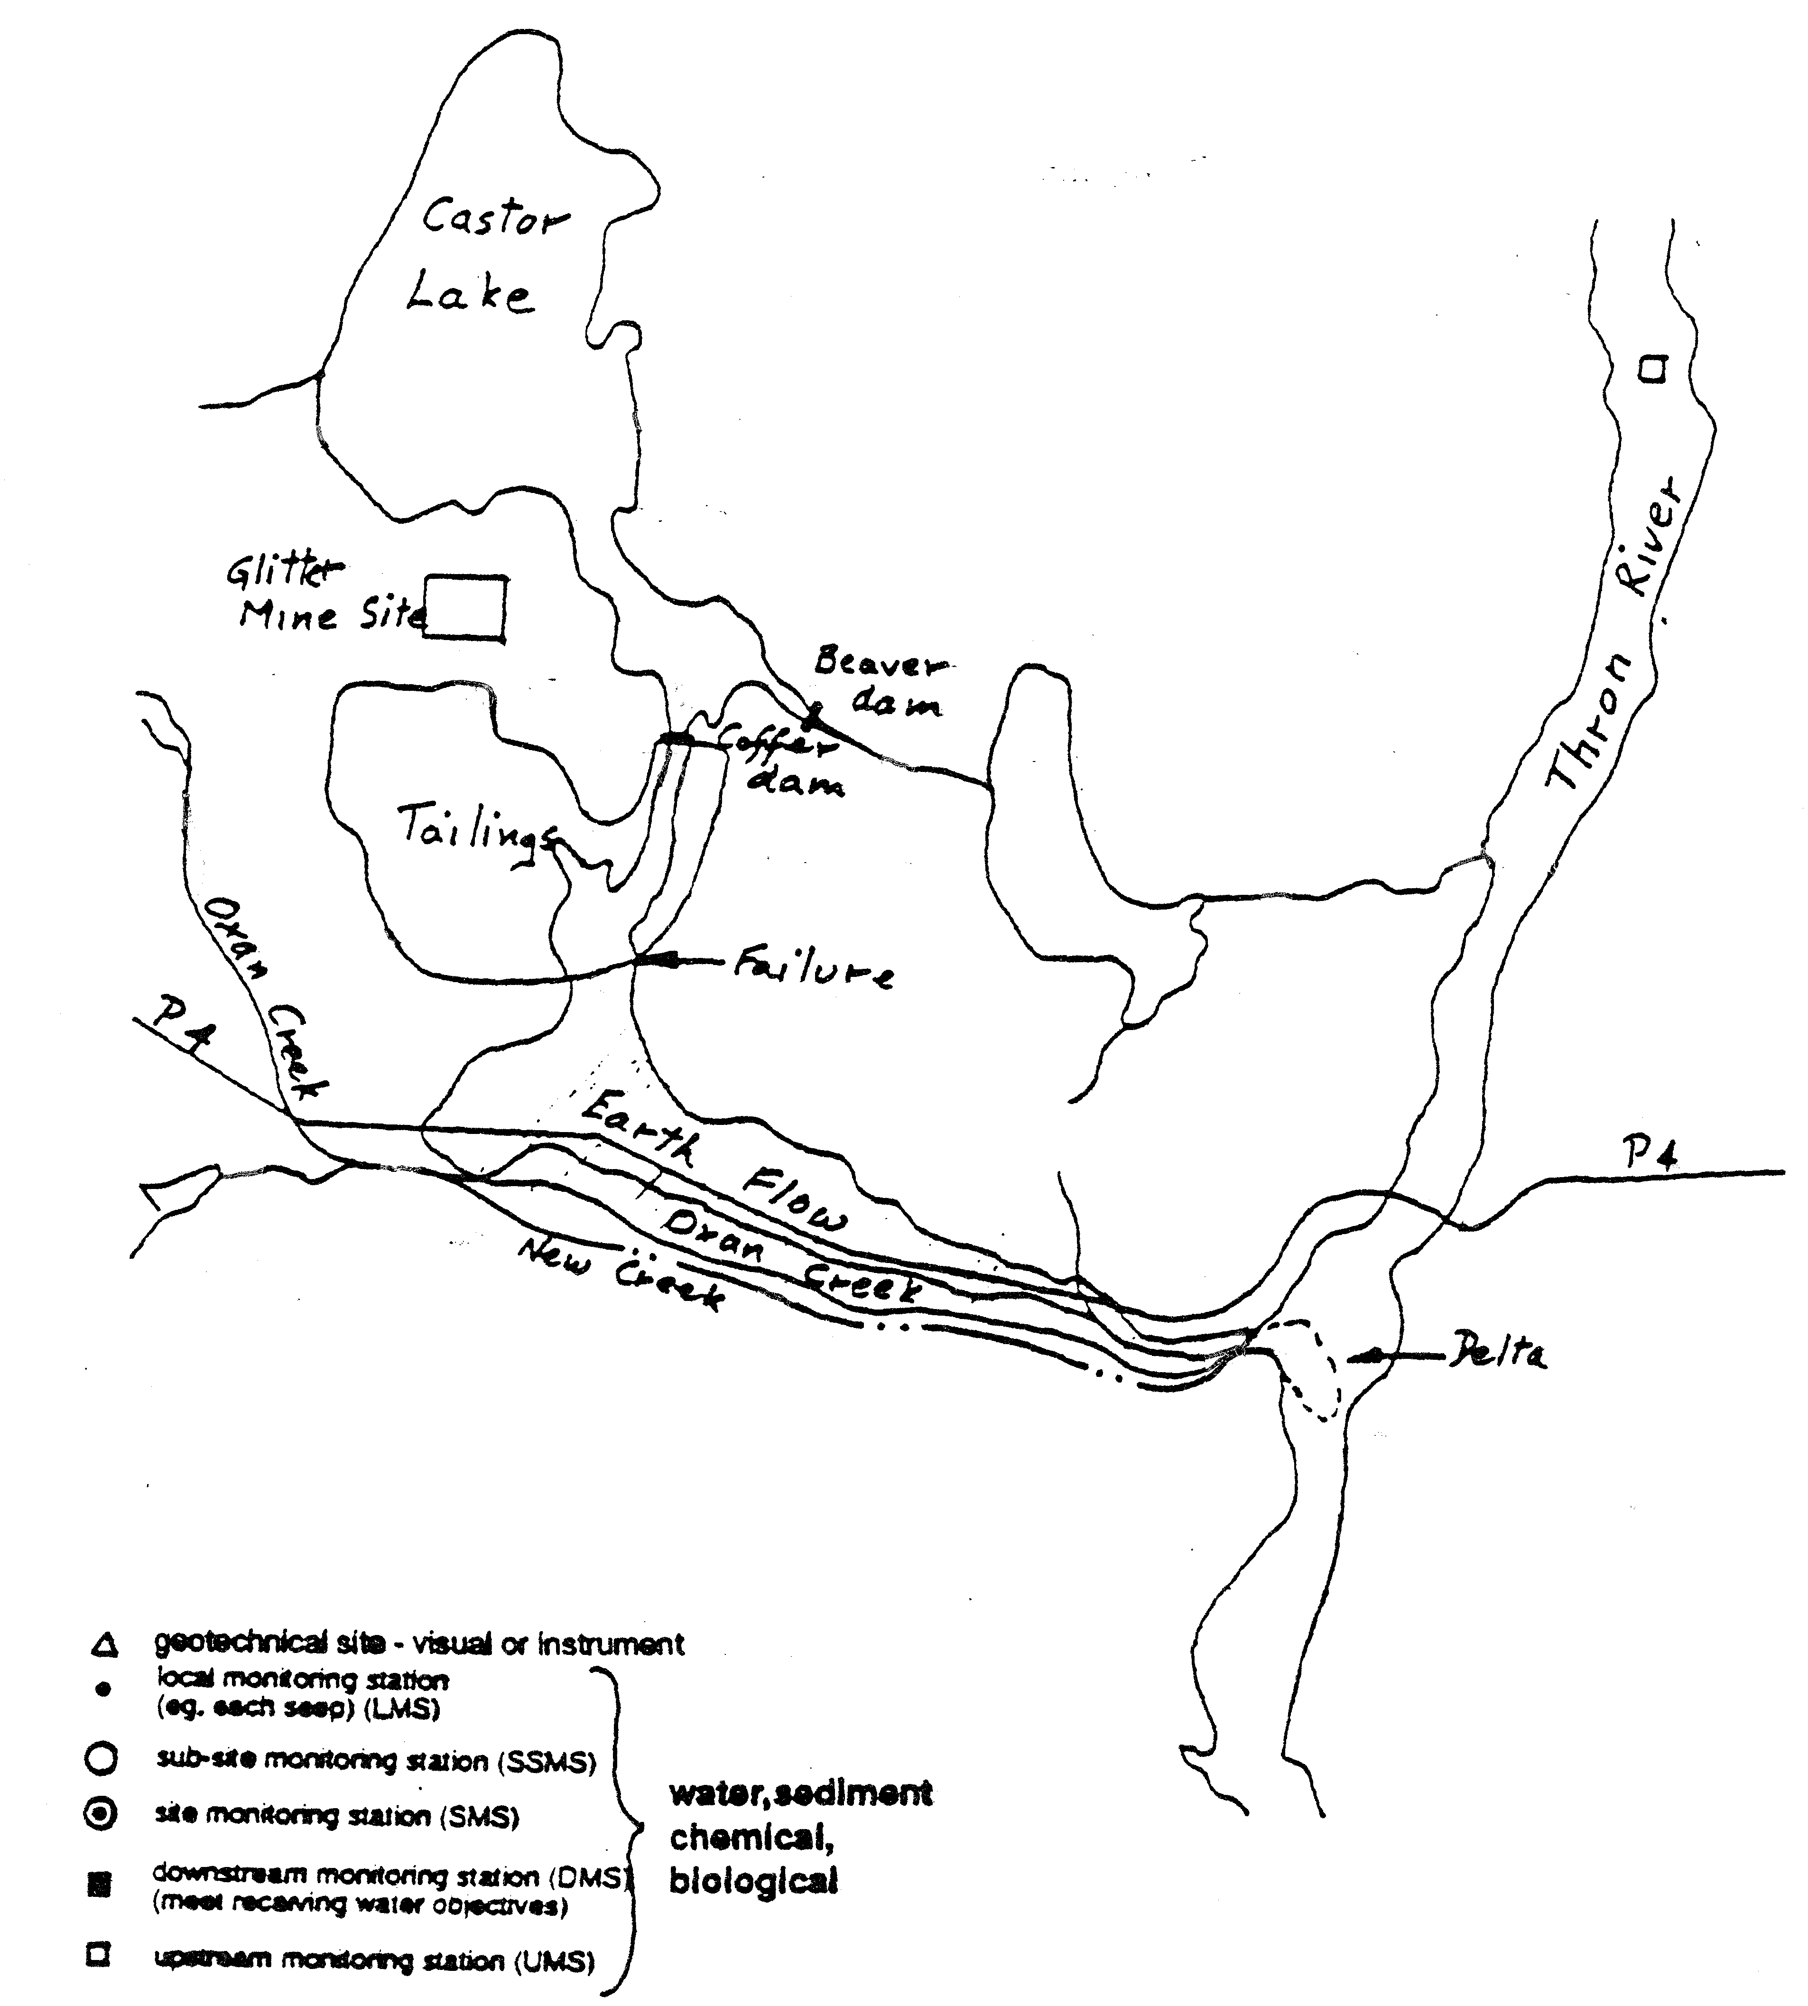
Over the years since closure, the natural dams from fallen trees were probably progressively built in stages, gradually increasing the level of the lake. It is estimated that the lake level may have risen by 2 meters or more since closure. As a result, instead of the tailings depositing in the lake, the lake encroached upon the tailings area thereby raising the overall phreatic level within the tailings.
Above normal precipitation during the month of October 1994 caused overtopping of the lowest part of the dam crest causing a breach in the south-east corner of the tailings area. This overtopping of the water resulted in rapid erosion of the tailings along the dam face with the width and the depth of the resultant gully increasing progressively as increasing volumes of water from both the dam and the lake passed through the breach. With the increasing flow and a high pore water pressure, liquefaction of the stored tailings material occurred producing a major mud slide of tailings through the breach and down the slope towards Oxan Creek to the south. The tailings flow, through the breach continued, supplemented by the waters of the lake. No temporary emergency measures could be undertaken to control the outflow, until the level of the lake was lowered sufficiently to reduce the flow through the breach.
It was essential to put in place temporary control structures to stop the flow of tailings into Oxan Creek and the Xan River. The buildings had been totally destroyed and the reconstruction of the highway could not be undertaken before the outflow of tailings and water were stabilised. These temporary measures were also to eliminate the possibility of another similar tailings dam failure at the same site, given the original construction of the dam was very inferior and not constructed to current acceptable engineering standards.
Tailings Dam
Restoration Philosophy
After an inspection of the tailings and adjacent areas were undertaken, and a review of the reasons for dam failure, two possibilities for the remediation of the site were considered:
            - Restoration of the tailings area to the original state.
            - Modification of the tailings site to eliminate future potential dam failures.
Remediation of Tailings Area to the Original State
Remediation of the tailings area to the original condition would include removing of the blockages at the lake outlet, to control lake levels, and the rebuilding of the breached portion of the tailings dam which would include suitable under-drainage measures.
The factors to consider are:
- The original tailings dams were not constructed to current acceptable engineering standards.
- The sidewalls of the breached section indicated that there were no internal drainage measures within the dam walls.
- The relative density of the sand tailings in the structural outer shell is considered to be loose.
- The downstream slope of the southern impoundment dams is not overly steep, generally ranging from 5H:1V to approximately 10H:1V.
It was observed that suspended solids, picked up by surface runoff from the tailings area, tended to settle out at the entrance to the lake, rather than remaining in suspension.
If the tailings area was restored, such that the water level within the tailings area was allowed to rise to a high enough elevation to enable runoff to flow by gravity to the lake, the eventual phreatic surface, within the tailings area and perimeter dams, would increase to a level that existed at the time of the dam failure.
Modification of Tailings Area
After all factors are considered the modification of the tailings area represents the best option. The construction of a permanent filter dam and the maintenance of pond levels within the tailings area as low as possible represents the most favourable alternative for both short and long term stabilisation of the site. Also, provided that the opening to the lake remains permanently blocked with a suitable dam, such that only minor seepage flows enter the tailings area, the only major water source within the tailings watershed would be due to local surface runoff and groundwater. The maintenance of low pond levels relates to levels at or near the base elevation of the tailings dam. Ponds upon the tailings would only serve to aggravate the pore water problem.
This option provides a filter dam, located across the breach, designed to trap suspended solids while permitting discharge water flows at basically the same rate as inflow into the tailings area. The crest of the filter dam would also act as an emergency overflow spillway to handle extreme runoff events. There would be a small holding pond immediately upstream of the dam. The short detention period would settle out the coarser solids and some of the finer particles in suspension. The retained water would be allowed to filter through the dam. As this pond would be serving as a settling pond it would require clearing out periodically.
Under extremely high flood conditions, or an unexpected emergency event the dam should be capable of being overtopped without danger of failure, thus allowing the safe release of excessive flow.
Tailings Surface Rehabilitation
As part of the stabilisation of the tailings area, it is essential that the surface of the tailings area be reshaped to create a gently contoured surface sloping towards a depression and pond in front of the filter dam. Recommended slopes should range between 5H:1V and 10H:1V except in the breached area where side slopes of 4H:1V are acceptable. Flatter slopes will reduce the flow velocities of surface runoff thus reducing erosion and gullying effects, as well as ensuring the long term stability of the slopes, and their amenability to the establishment of vegetation. Long term rehabilitation of the slopes by surface revegetation or riprap is the objective. It is recommended that a detailed grading plan be prepared defining the desired contoured surface prior to any implementation of the landscaping and revegetation programme.
The sequences of activities to achieve this programme include landscaping, site preparation, surface protection during the establishment of vegetation and soil amelioration.
Acidic Drainage
While investigating the site, it was discovered that one section contained sulphide tailings that are acid generating. Due to the failure in the main part of the tailings these sulphide tailings may in the future erode into the adjacent rehabilitated recontoured portion of the disposal site.
It therefore became necessary to implement remedial procedures. These tailings cannot be submerged because of the danger of raising the phreatic level. This leaves a number of choices. These are to transport the tailings to an appropriate designated site or to cover them. Alternatively, to transport them elsewhere is not a viable option because of the large volume involved and the lack of a nearby appropriate certified site. It is therefore necessary to cover them.
There are three options for covers, each with their own assets and drawbacks. There is the simple cover, the complex cover and the composite cover.
Oxan Creek and Forested Areas
The flow of the liquefied tailings covered 150 000 square meters which included Oxan Creek, the adjacent forested areas and a number of residences. The depth of the tailings has a minimum thickness of 2 meters. The width of the flow is half a kilometre wide narrowing down to 100 meters where it enters the Xan River, where it forms a delta and the plume downstream. It follows the old course of the Oxan Creek and one kilometre of Highway P4.
There are a number of options to restore the flow of water down Oxan Creek which has a large watershed and is a perennial stream. The options are:
Option 1
Excavate the bed of Oxan Creek and restore the old water course, remembering that the tailings are deep and over one and a half kilometres long.
Option 2
Excavate a new channel outside the tailings but parallel to them.
Monitoring
As a result of the failure a certain amount of contamination was introduced into the area. In addition, because of the failure the physical characteristics of the site need to be monitored, both the new and the old features.
Exercises
Why, in your opinion, did the dam fail so easily?
How was it determined which method was used in constructing the dam? It was not in the records of the mining company.
The investigators reported that there were no special under-drainage or protective features on the dam walls. What would you look for if you were an investigator?
Would you need to use any instrumentation to arrive at that decision?
What would be the initial effect of the encroaching water raising the phreatic level in the tailings?
Which are the points at which temporary remedial measures should be put in place to control the outflow?
What are the specific problems at each location?
What method can be used to stop the solid flow of the liquefied tailings and yet allow for the draining away of the water? Describe the structure?
In considering remediation of the tailings to the original state, there are a number of factors to be considered. Review the following factors and give your opinion as to whether they are positive or negative.
The factors to consider are:
- The original tailings dams were not constructed to current acceptable engineering standards.
- The sidewalls of the breached section indicated that there were no internal drainage measures within the dam walls.
- The relative density of the sand tailings in the structural outer shell is considered to be loose.
- The downstream slope of the southern impoundment dams is not overly steep, generally ranging from 5H:1V to approximately 10H:1V.
It was observed that suspended solids, picked up by surface runoff from the tailings area, tended to settle out at the entrance to Castor Lake, rather than remaining in suspension.
If the tailings area was restored, such that the water level within the tailings area was allowed to rise to a high enough elevation to enable runoff to flow by gravity to Castor Lake, the eventual phreatic surface, within the tailings area and perimeter dams, would increase to a level that existed at the time of the dam failure.
From these data would you recommend restoring the site to its original configuration?
How would you maintain the settling pond?
Under extremely high flood conditions or emergencies, how would the excessive flow be safely released. Also what protective features would be built into the structure?
Tailings Surface Rehabilitation
What type of equipment would you use for the landscaping, recognising that cost is a factor?
Recognising that not all parts of the site are amenable to vegetation, what techniques would you use to inhibit wind and water erosion?
Recognising that tailings are relatively sterile, give examples of preparing a “soil” for revegetation?
In selecting vegetation for rehabilitation, what are the most appropriate species?
Acidic Drainage
The composite or multi-layered cover is the only appropriate solution to contain the acid generating sulphide tailings at this site. Graphically illustrate the features of a composite cover and explain the function of each layer?
Oxan Creek And Forested Areas
There are two principal options to restore the stream flow on Oxan Creek. In your opinion which is the better option, taking into consideration cost, materials handling, erosion and contamination? Give both the pros and cons for your decision by describing what activities would be necessary in each case?
Monitoring
As both chemical and physical monitoring are necessary to protect the integrity of the site and the surrounding areas, on the attached map locate the extent of the monitoring envelope, the monitoring points and stations. In each case state the name of the station (if applicable), the function, and the method used to collect the data?
Further exercises to be developed by the trainer.

The details of the country of Udamax are an extension of those given in “Hazardous Waste : Policies and Strategies”, UNEP 1994

